**Application Vending Machine**

The program has following main menu:

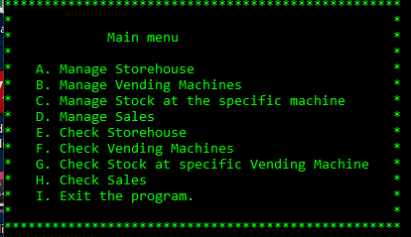

To start selling products from vending machine you need:

1. Add products to the storehouse
2. Add a new vending machine with the stock
3. Add products to the existing stock

Examples of sub menus:

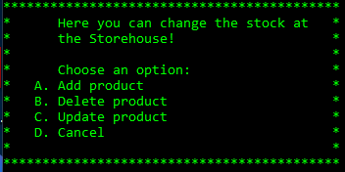

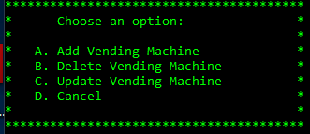

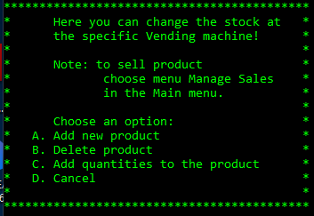

The program allows you to check storehouse, for example:

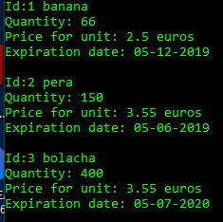

To check vending machines, for example:

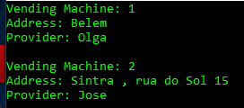

To check stock at vending machine, for example:

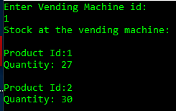

The example of selling product (the program checks if there is enough quantity at the stock):

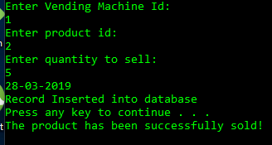

Finally we can check all the sales that have been stored in database:

